Roster Management Service.

**Index**

|  |  |  |
| --- | --- | --- |
| Sr No | Content | Page No |
| 1 | Introduction | 3 |
| 2 | Architectural Design | 3 |
| 3 | High Level Design | 6 |
|  | 3.1 E-R Diagram | 6 |
|  | 3.2 Page Navigation Diagram | 7 |
|  | 3.4 Deployment Diagram | 12 |
| 4 | Low Level Design | 13 |
|  | 4.1 Database Design | 13 |
|  | 4.2 Stored Procedure | 16 |
|  | 4.3 Details Of Page Navigation | 17 |

* **Introduction:**

This document is meant for the description of the structure and the database which we are using in this project. This document gives brief description about Architecture of the system, E-R diagram of the system and the table descriptions, the page navigation diagrams and the detail description for the page navigation.

* **Architecture Design:**

Following diagram shows the details of the Roster Management Service architecture.

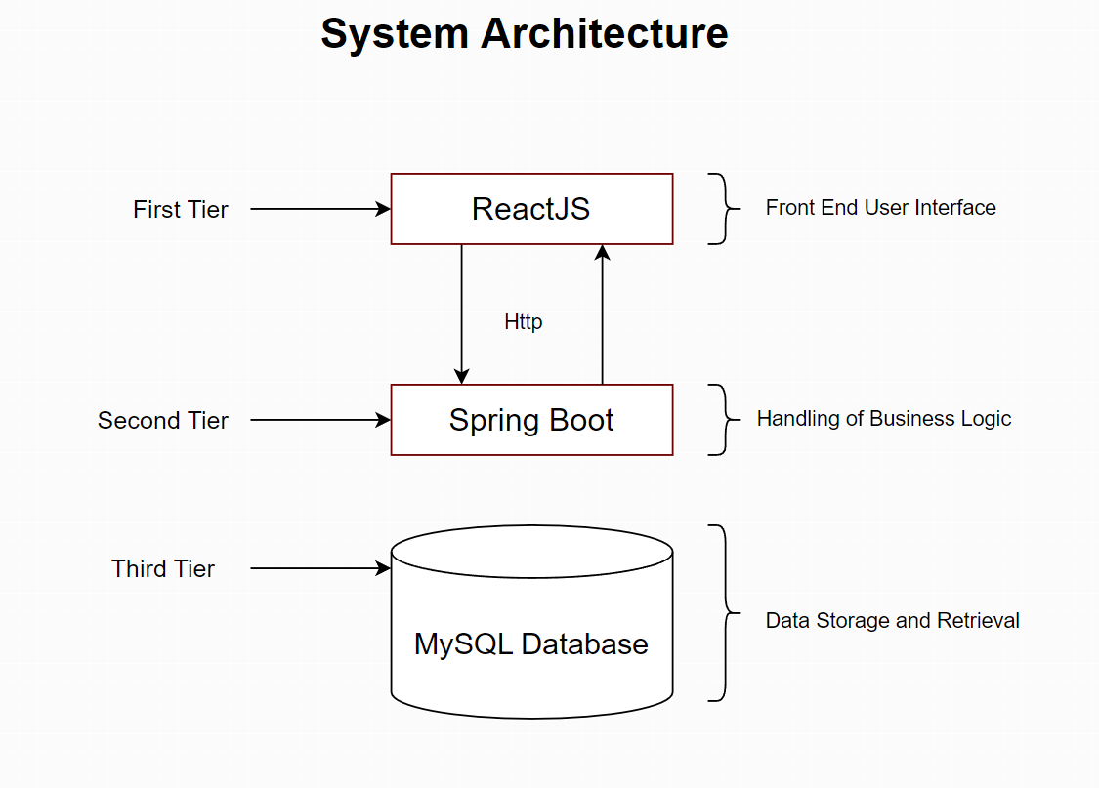

This System consist of three tiers as listed below,

* First tier
* Second tier
* Third tier

**First Tier:**

It is also called as Presentation tier; it is responsible for displaying the application's user interface. It is typically implemented using ReactJS. ReactJS is a JavaScript library that is used to build user interfaces. It is known for its component-based architecture, which makes it easy to create reusable and maintainable code.

**Second Tier:**

It is also called as Service tier; it is responsible for handling the application's business logic. It is typically implemented using Spring Boot. Spring Boot is a framework that makes it easy to build Java applications. It provides a number of features that make it easy to configure, test, and deploy Java applications.

**Third Tier:**

It is also called as Data tier; it is responsible for storing and retrieving the application's data. It is typically implemented using MySQL. MySQL is a database that stores data in tables. Tables are made up of rows and columns. Each row represents a single record, and each column represents a single piece of data about that record

* **High Level Design:**
* **E-R Diagram:**

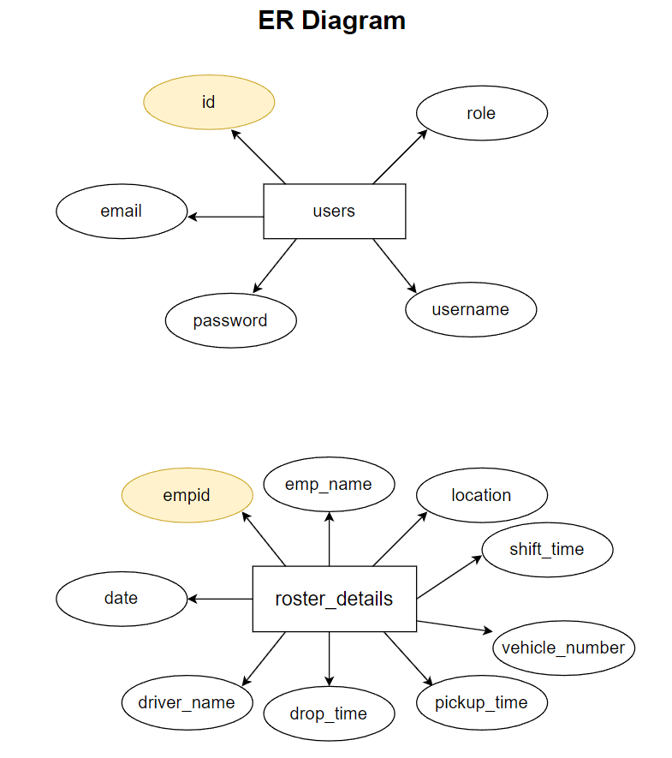

Above E-R Diagram shows that database of Roster Management System consists of following entities:

* **users:**

This entity consists of id, role, email, password and username.

* **roster_details**

This entity consists of empid, emp_name, location, shift_time, vehicle_number, pickup_time, drop_time, driver_name, date

* **Page Navigation Diagram:**
* **Employee/Driver**

Following diagram explains the page navigation for the this module:

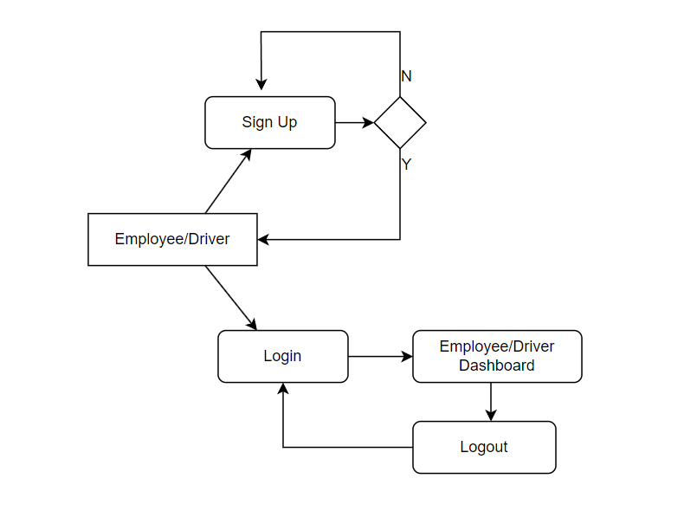

* **Manager**

Following diagram explains the page navigation for the Manager module:

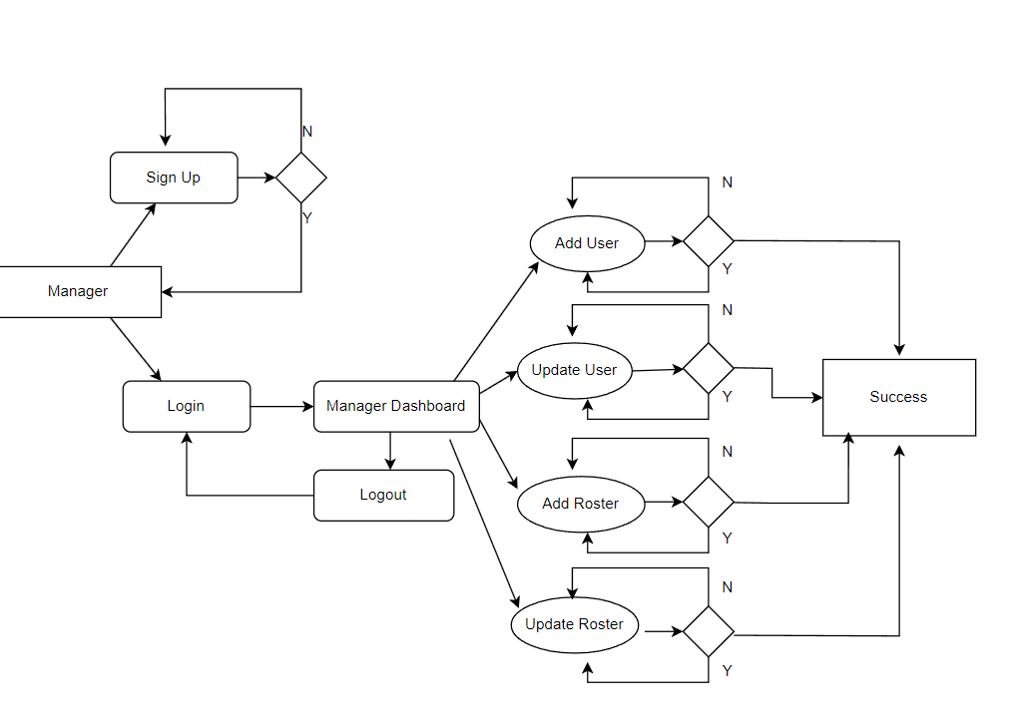

* **Transport Authority**

Following diagram explains the page navigation for this module:

``

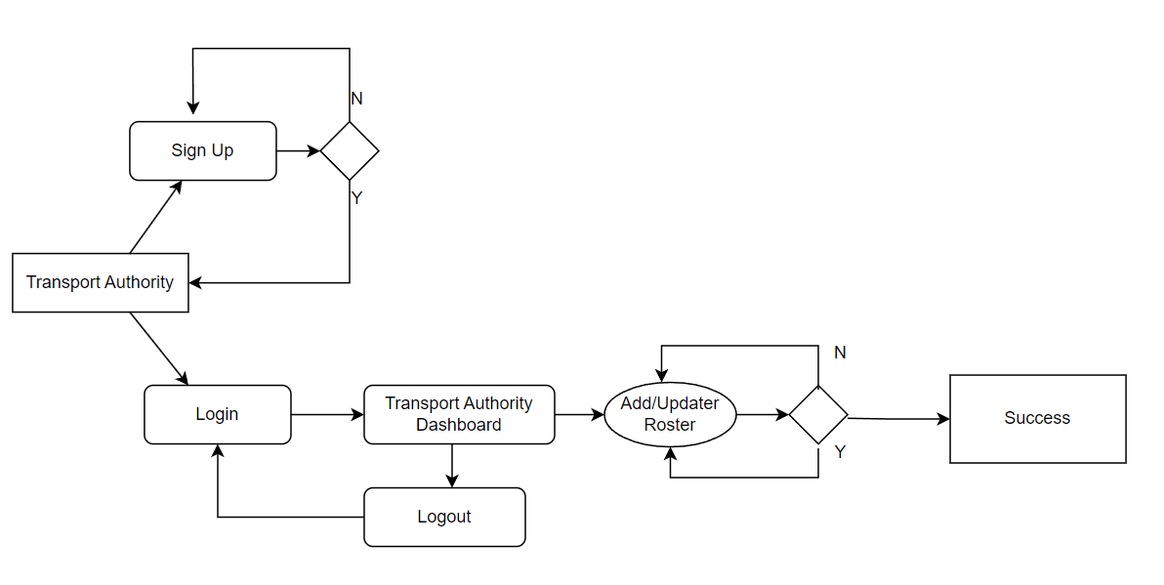

* **Low Level Design:**
* **Database Design:**

**1] Tbl_users**

|  |  |  |  |  |  |
| --- | --- | --- | --- | --- | --- |
| **Field** | **Type** | **Null** | **Key** | **Default** | **Description** |
| id | BigInt | No | Primary key | Null | User ID |
| email | Varchar(225) | No |  | Null | Email ID |
| password | Varchar(225) | No |  | Null | Password |
| role | Varchar(225) | No |  | Null | Type of User |
| username | Varchar(225) | No |  | Null | Username |

**2] Tbl_roster_details**

|  |  |  |  |  |  |
| --- | --- | --- | --- | --- | --- |
| **Field** | **Type** | **Null** | **Key** | **Default** | **Description** |
| empid | BigInt | No | Primary key | Null | Employee ID |
| date | Varchar(225) | No |  | Null | Date when employee is available |
| driver_date | Varchar(225) | No |  | Null | Date when driver is available |
| drop_time | Varchar(225) | No |  | Null | Timing of drop |
| emp_name | Varchar(225) | No |  | Null | Employee name |
| location | Varchar(225) | No |  | Null | Location for pickup |
| pickup_time | Varchar(225) | No |  | Null | Pickup time |
| shift_time | Varchar(225) | No |  | Null | Shift time |
| vehicle_number | Varchar(225) | No |  | Null | Vehicle Number |